# Q1. CI/CD PIPELINE

**Building pipeline-**

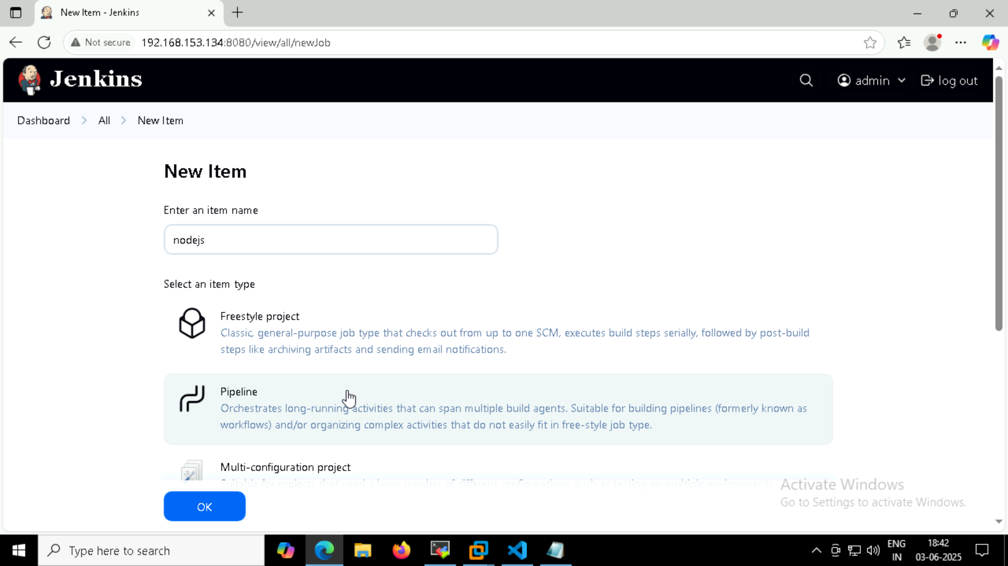

Setting up credentials(for docker login & k8s):

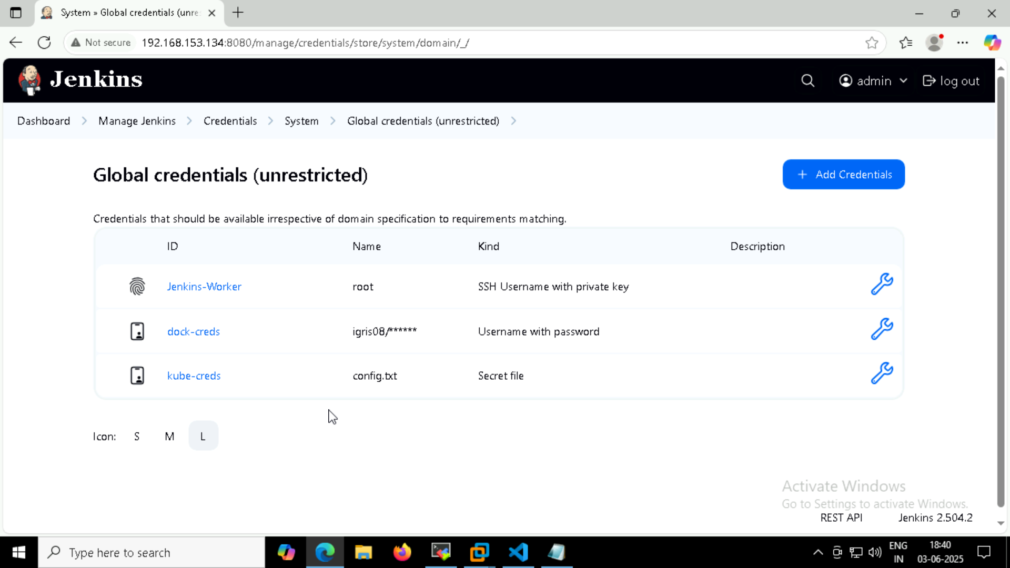

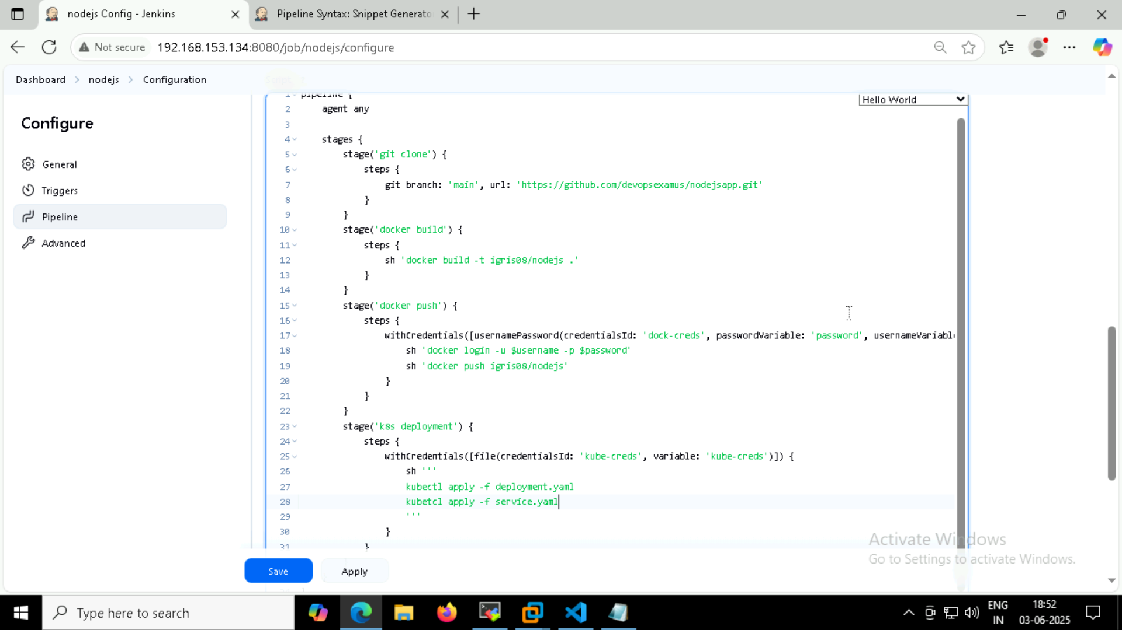

**Docker build-**

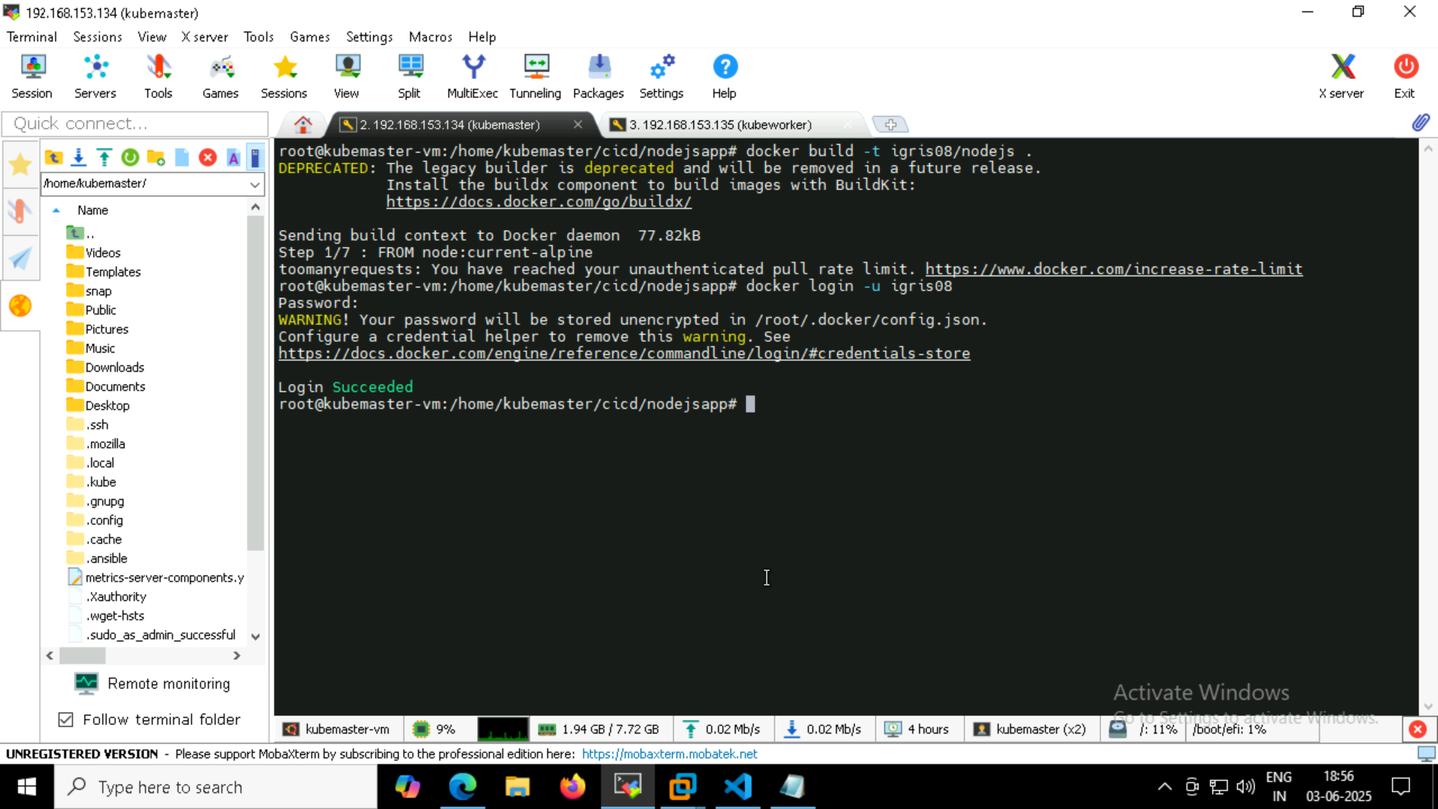

* While building docker image, I encountered rate limit issue. So I did docker login

(**Please note** – my dockerhub username is igris08, I had kept it long back during training)

After docker login, image build worked.

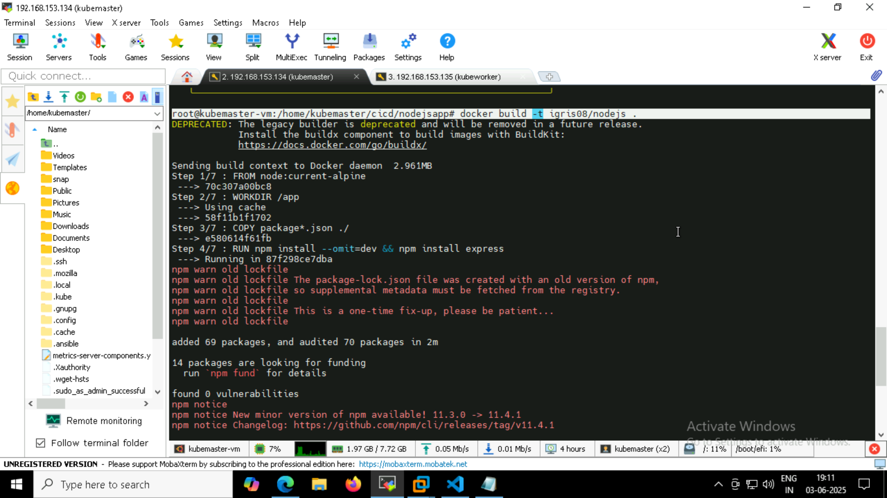

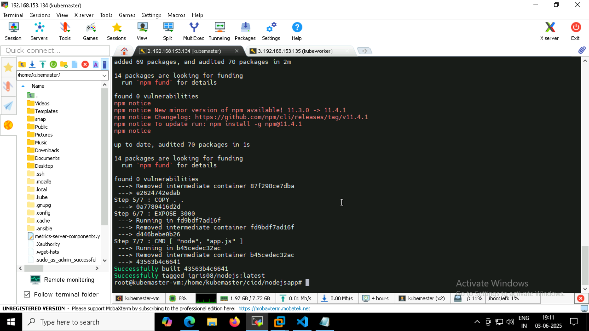

Docker image created-

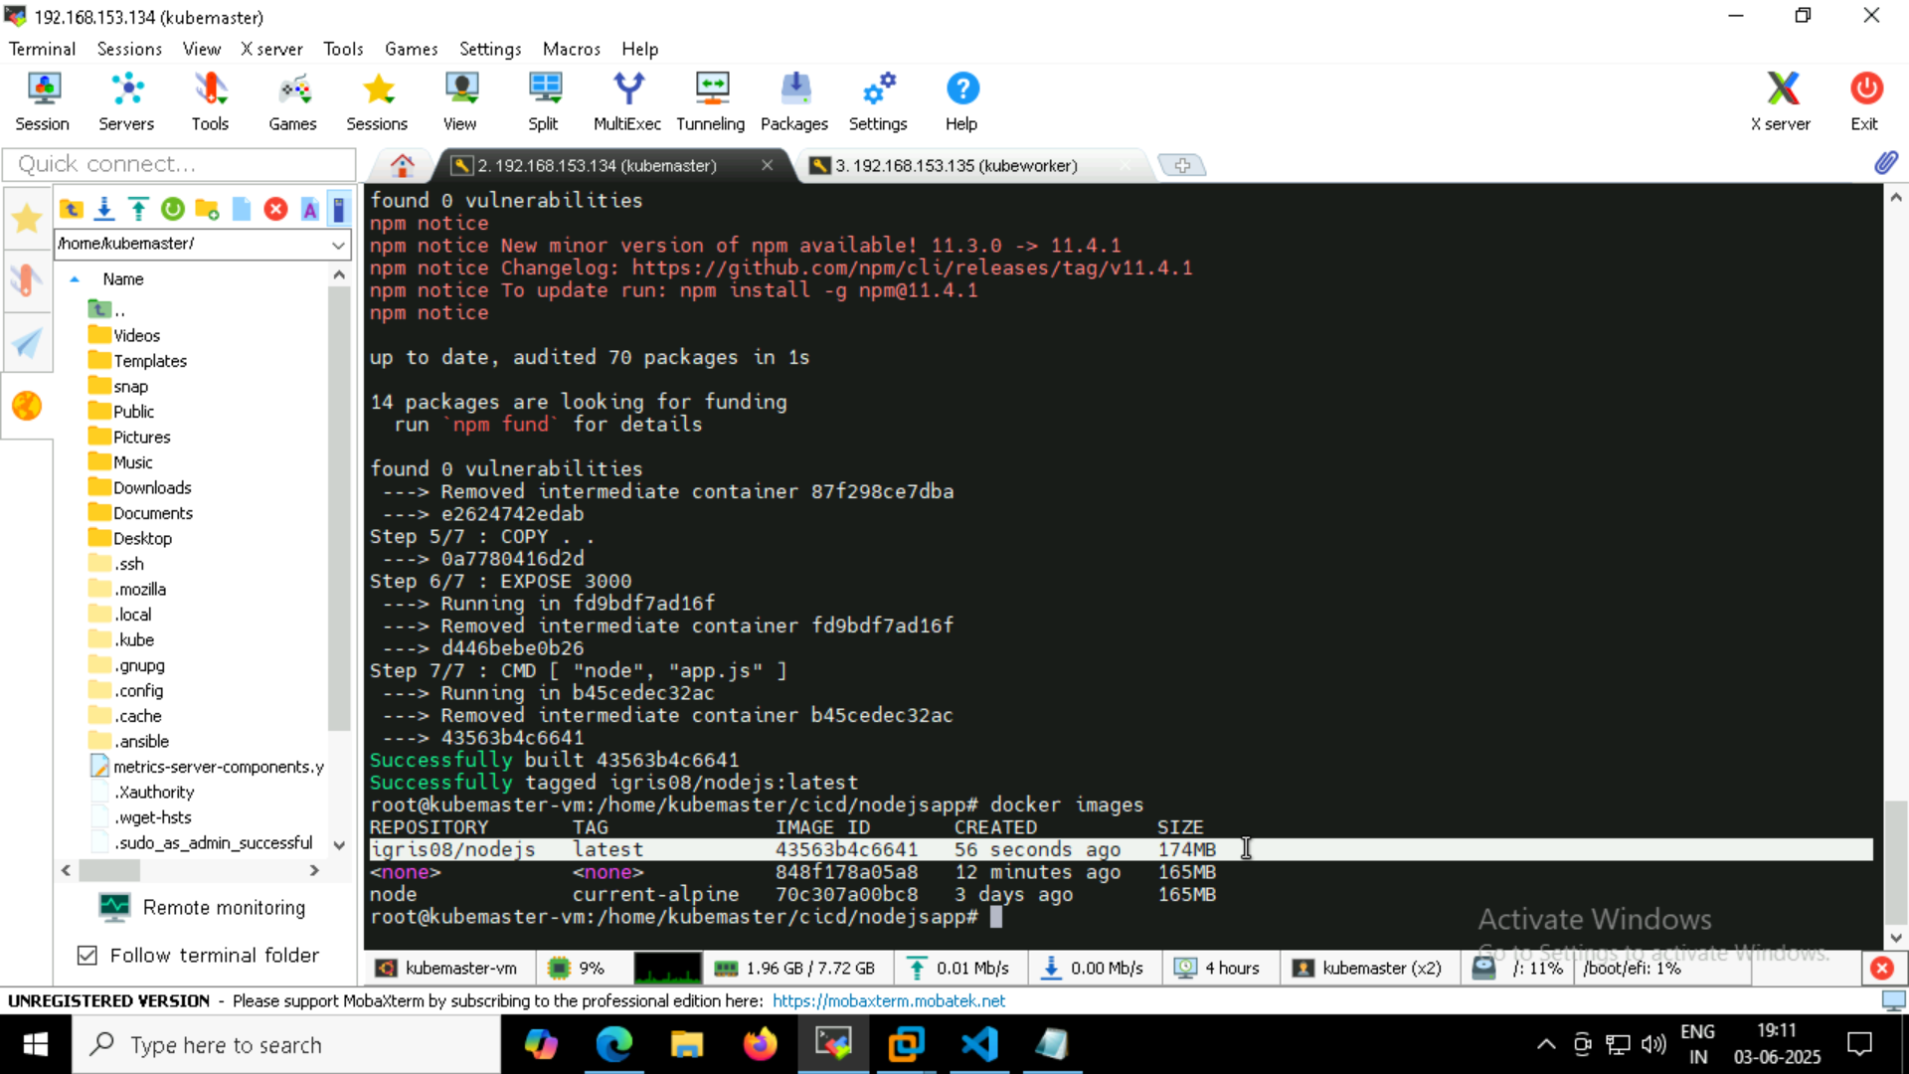

**Creating deployment yaml -**

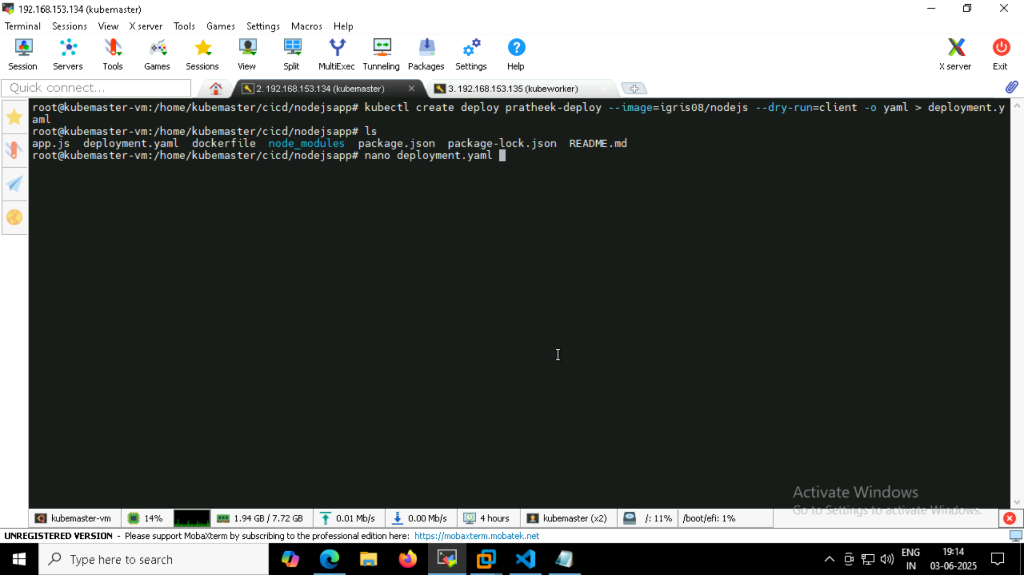

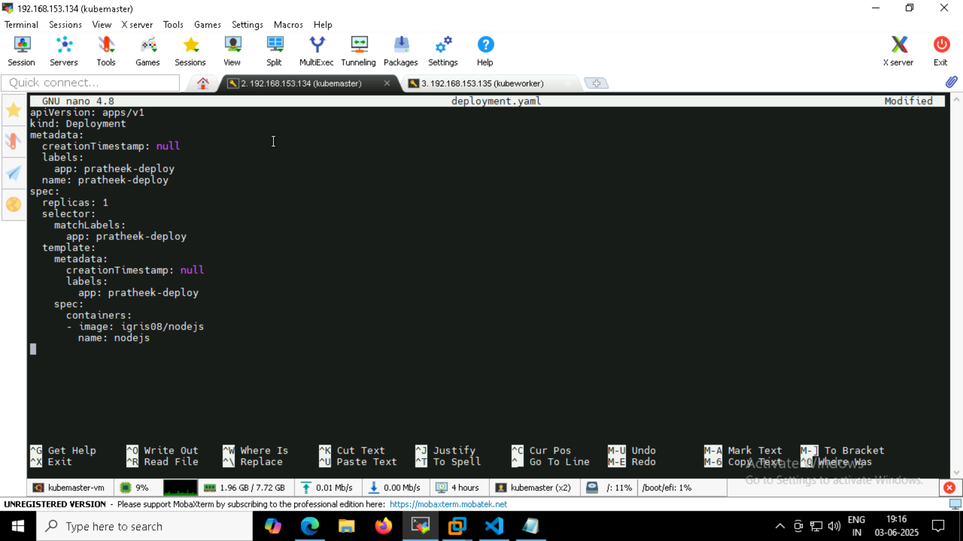

Kubectl applying deployment.yaml

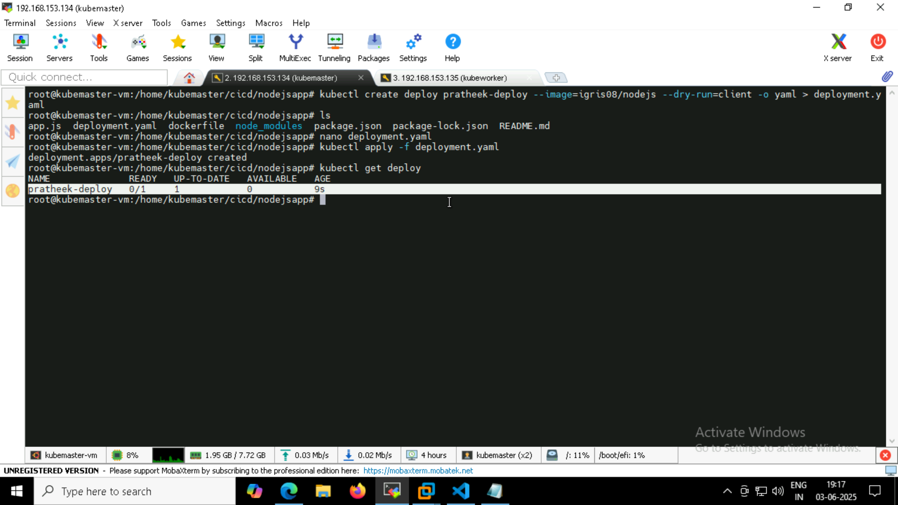

Service yaml-



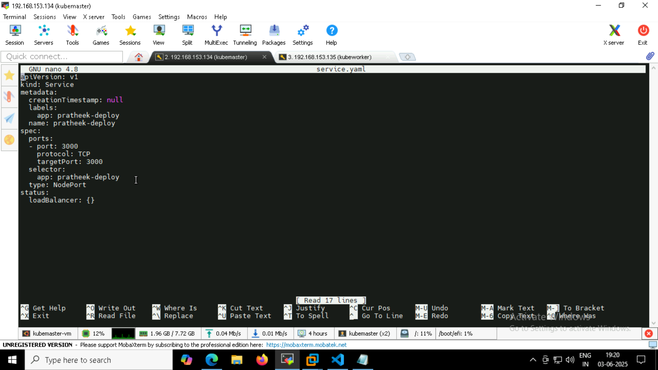

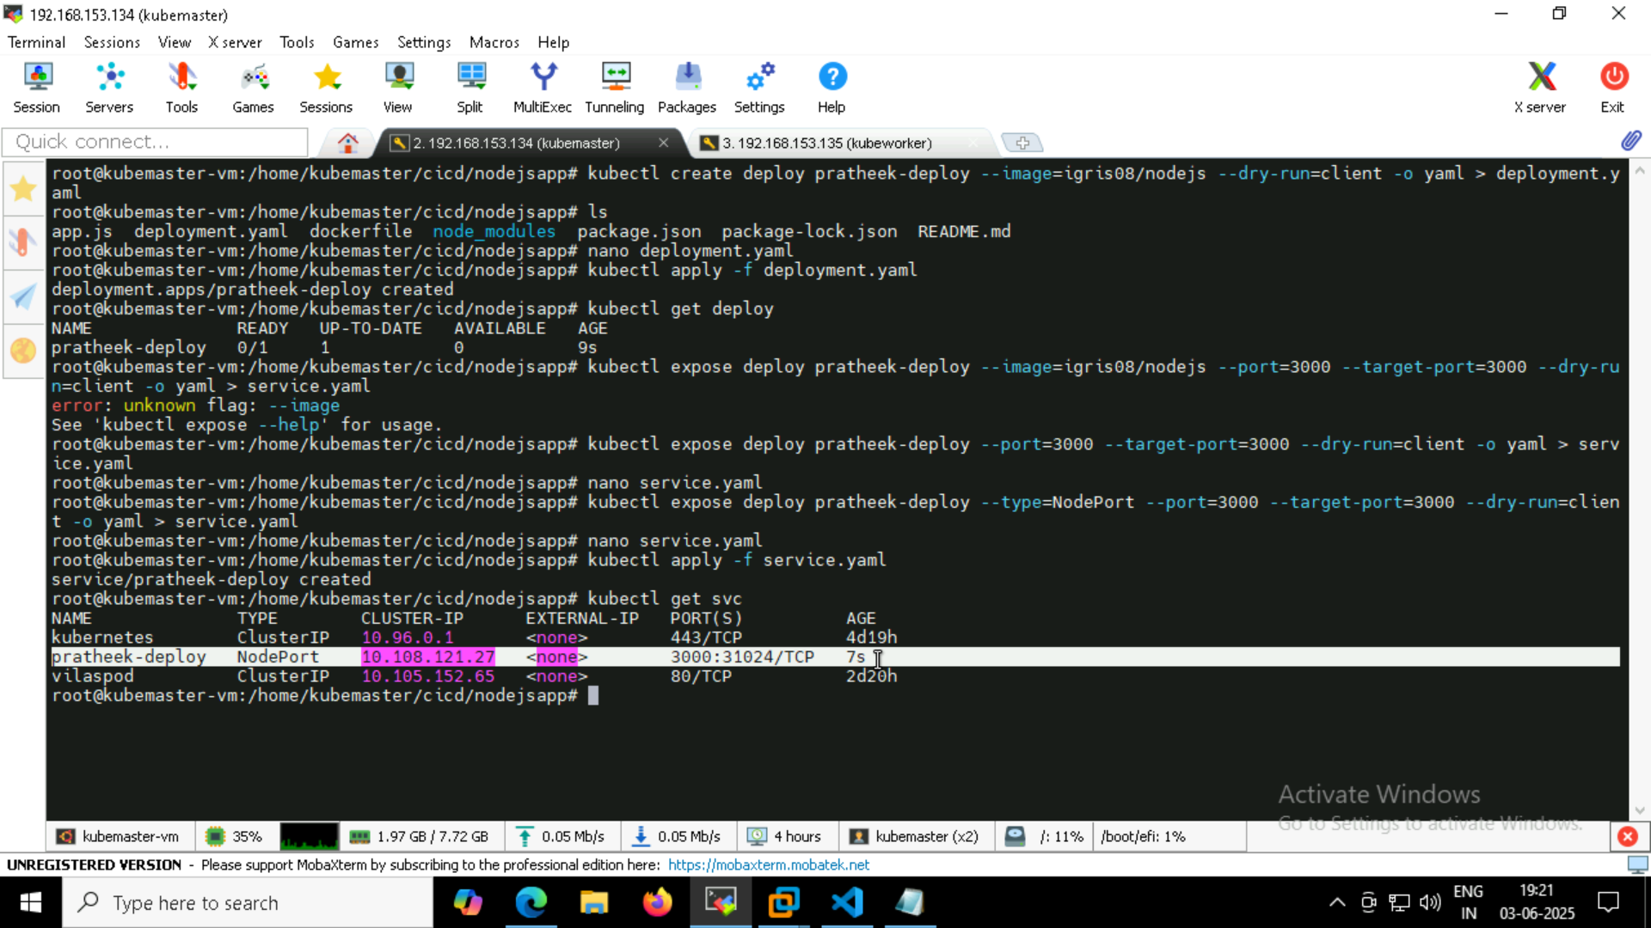

**Moving deploy & service.yaml to Jenkins workspace-**

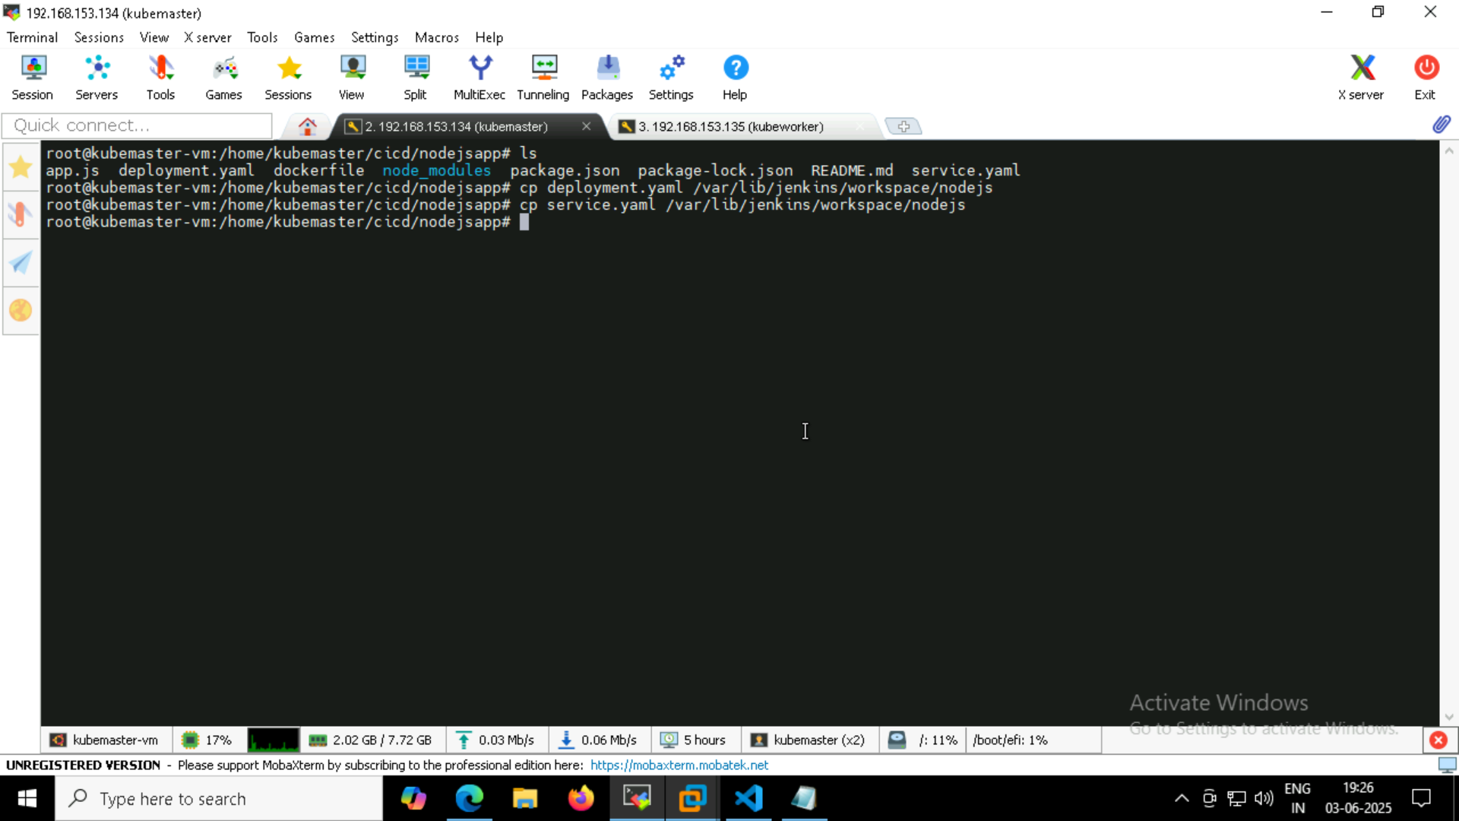

**Build & test –**

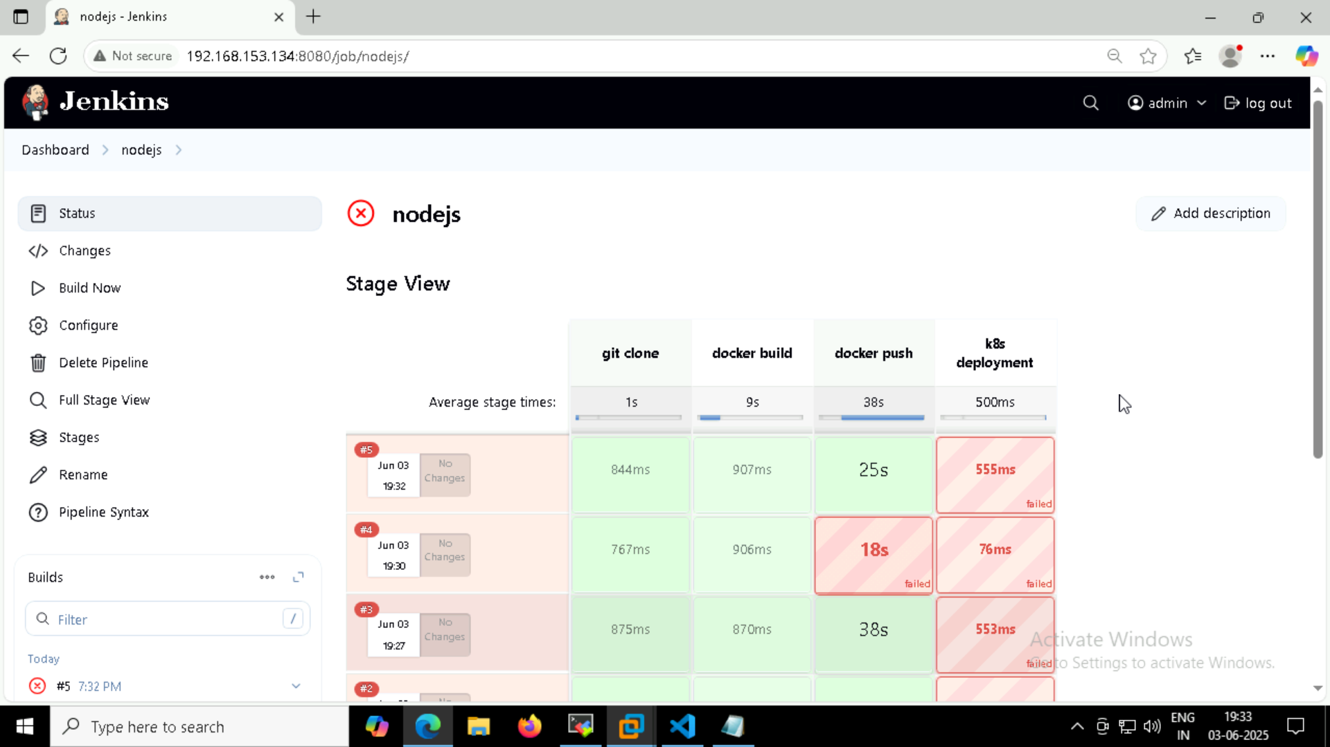

**K8s deployment didn’t work because of rrate limit issue.**

**Console oupput-**

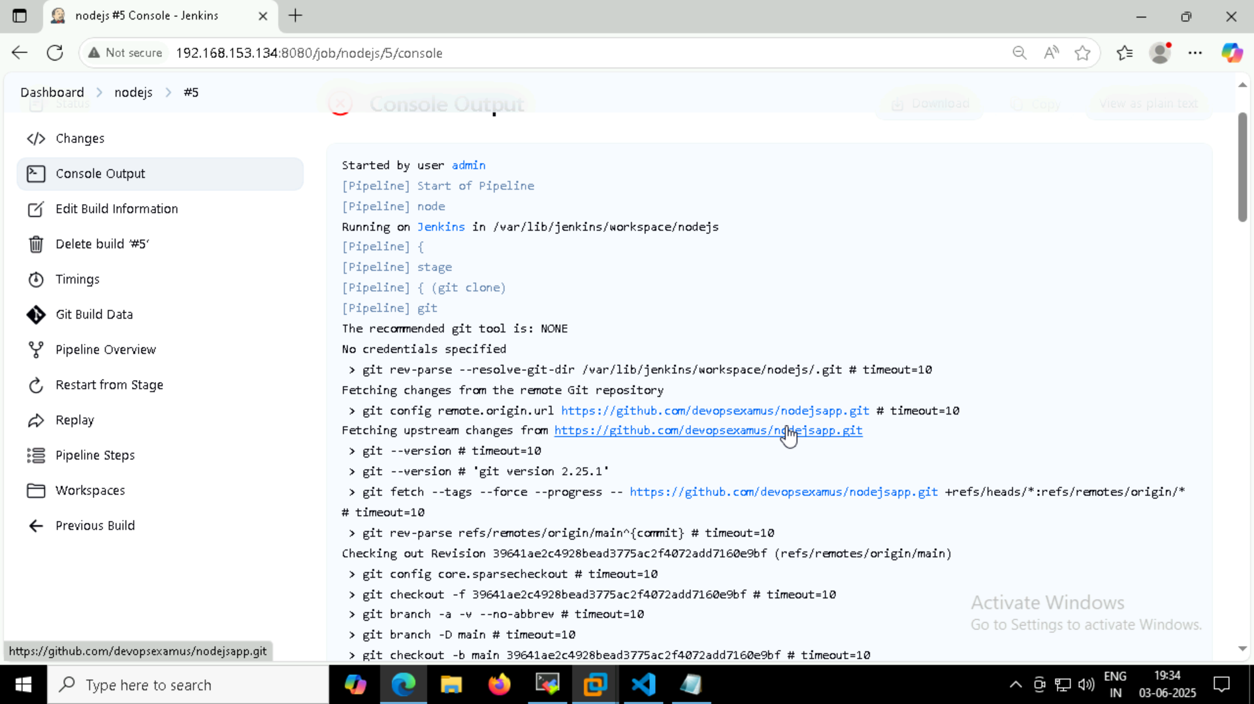

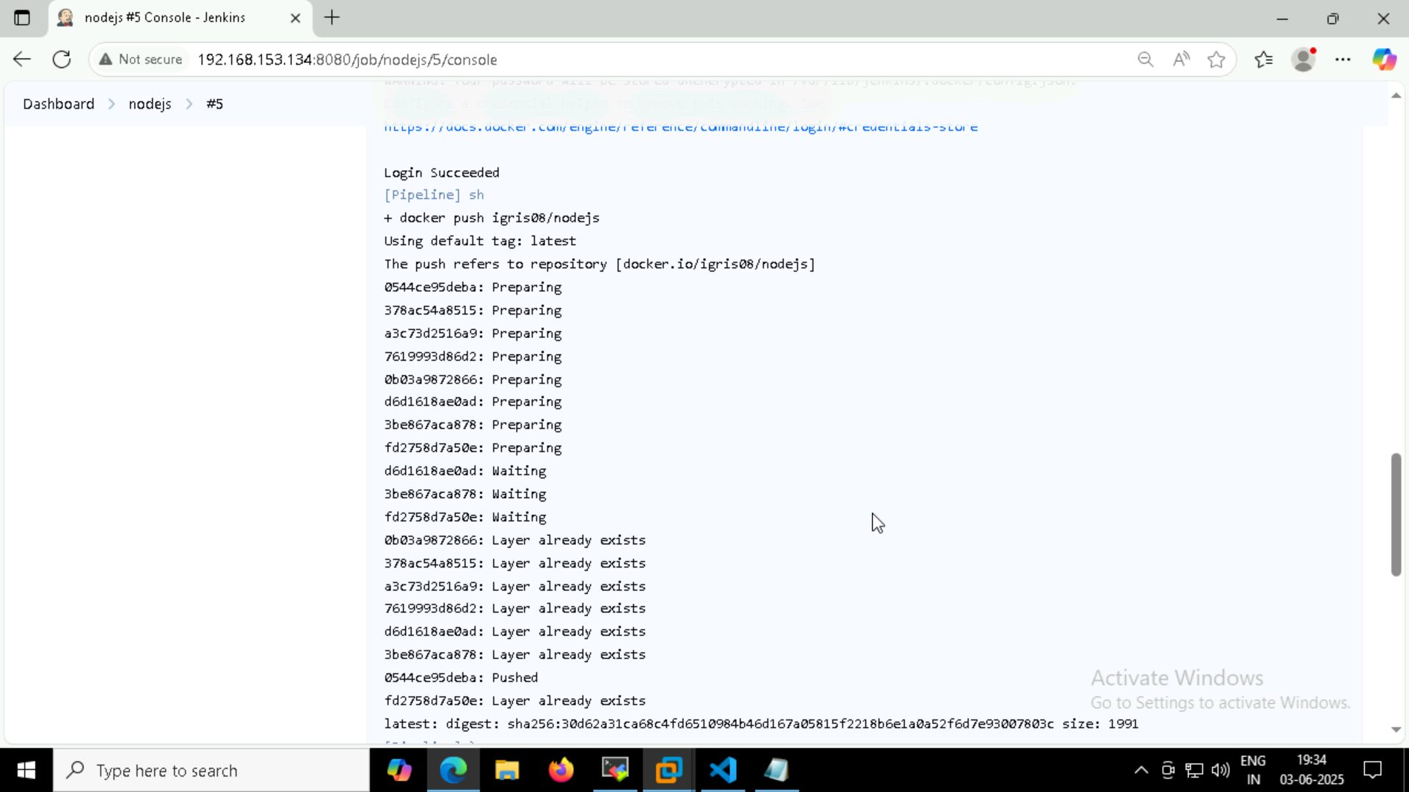

**Since I had rate limit issue, I will run and show the nodejs inside the pod -**

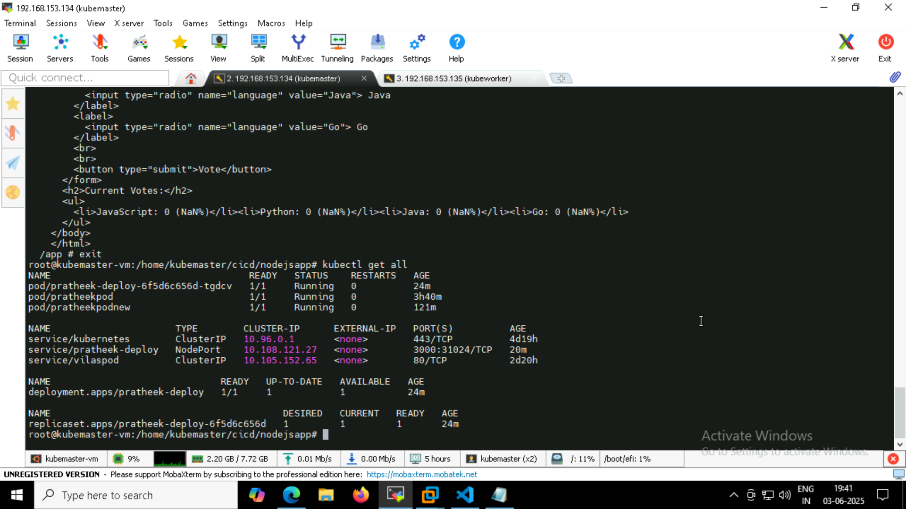

**Accessing index.html inside pod -**

Wget 192.168.153.134:31024

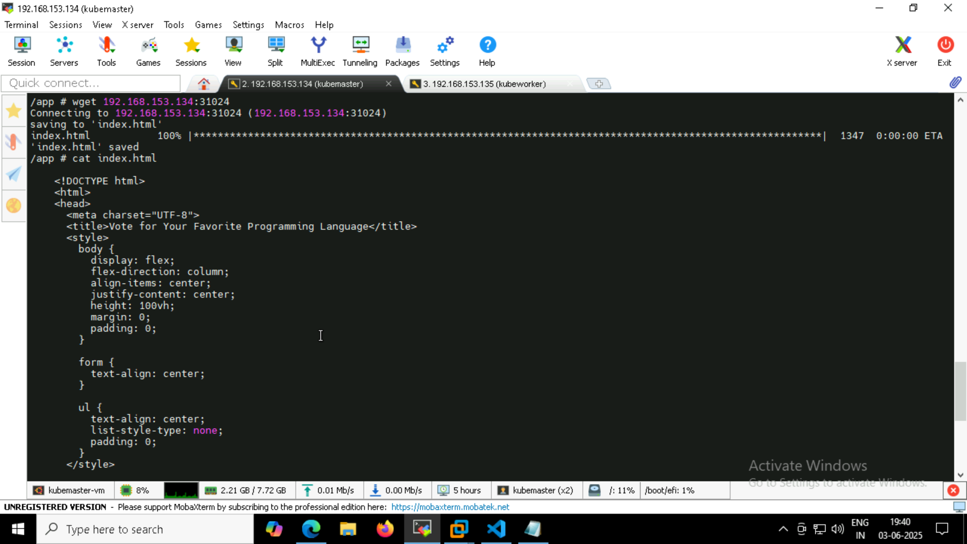

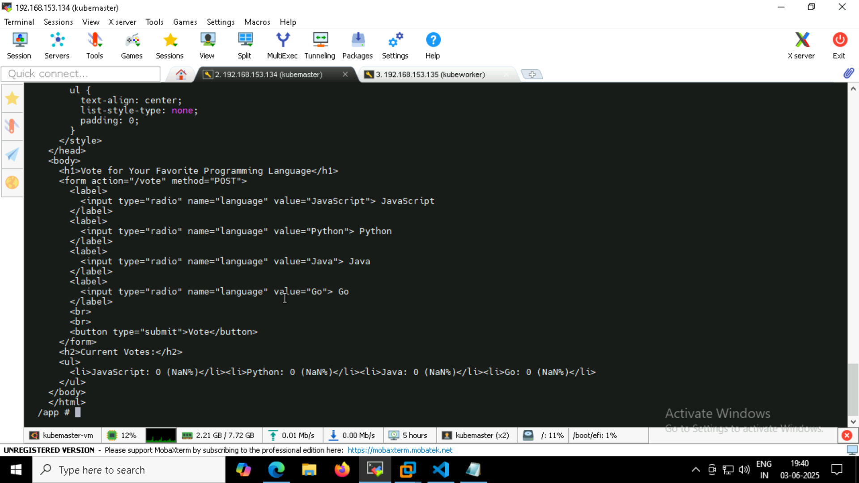

**So nodejs is running inside the container!**